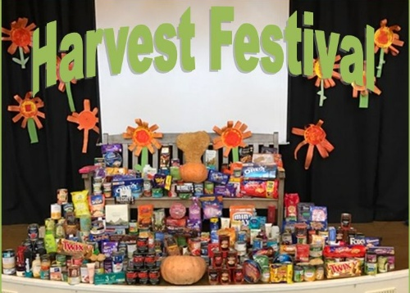

We are having a Harvest Assembly on Friday 4th October. We would like to distribute our Harvest boxes to the elderly in the Community. So Please help us by sending in empty shoe boxes and tinned goods.
Thank you from St Gregory’s School Council Team

